**Laundry Management System (LMS)**

**IT Squad**

Block 1

Lady Ann Mariel S. Bravo

Lilibeth G. Cruz

Erica Mae P. De Vera

Erl John Larrobis

Jim Michael V. Enrico

# Executive Summary

The IT Squad began as a campus group in an IT course in the subject of new ventures at Phinma-University of Pangasinan. It was founded by Lady Ann Mariel Sabangan Bravo after she was assigned as a leader in our group in the year 2022. We continue it and we build a friendship that has the same goals, which is why the IT squad was created. Themission of IT Squad is to create a new venture solution through IT industry innovation to help individuals by making ideas realistic and valuable and not consuming time.

The laundry business has seen an explosion of growth over the years. While this industry is a lucrative one, there are also problems that go along with owning and operating a laundry business. Laundry owners are doing manual reports and inventory not just for their products but also for their customers, which will lead to more time, cost, and service quality. The IT Squad provides a Laundry Management System that enables the laundry business to manage day-to-day operations, orders, processes, billing, and delivery management in an automated environment. It can help businesses solve some of their problems by making business operations tighter and more efficient, like better inventory management. When inventory management is perfect, it generates several benefits, like more efficient operations, which reduce costs, time, and improve service quality. This will greatly assist the business owner in managing their business and will replace the existing manual, paper-based system. It can help you reduce operating costs and run a highly efficient commercial laundry business.

# Business Ideas

**Laundry Management System (LMS)**

The Laundry Management System enables the laundry business to manage day-to-day operations, orders, processes, billing, and delivery management in an automated environment. It provides a solution for businesses to manage their laundry process with ease and efficiency. It also allows business owners to keep track of their employee’s performance and productivity through real-time reports. This system contains admin and staff. The admin can manage the staff, like deleting, updating, adding new users, and also updating information. The staff can manage selected data controlled by the admin. The system also has its own inventory. This system is friendly for users and easy to understand. The system will be developed using PHP and a MySQL database, using HTML, CSS, JavaScript, Modal, and Bootstrap.

**Features of the Project**

* **Dashboard**

The dashboard will contain Home, Laundry List, Laundry Category, Supply List, Reports, Users, Total Profit Today, Total Customer Today, Total Claimed Laundry Today.

* **Laundry List**

The Laundry List can Show Entries, Add New Laundry, Date, Customer Name, Status, Edit, Delete, and Search.

* **Laundry Category**

The Laundry Category has a Laundry Category Form, Price per Kg, Name, Edit, and Delete.

* **Supply List**

The Supply List contains the Laundry Supply Form, Number Entries, Edit, and Delete.

* **Reports**

The reports have a Date From, Date To, Customer Complete Name, Total Amount, Filter, Total, and Print.

* **Inventory**

This will Show Entries, Search, Supply Name, Stock Available, Supply In/ Out List, Manage Supply, Date, Supply Name, Quantity, Type, Edit, and Delete.

* **Users**

In this section there are Numbers of Entry, Name, Username, Action, Edit, Delete, and add New User.

* **Total Profit Today,**
* **Total Customer Today**
* **Total Claimed Laundry Today**

This will greatly assist the business owner in managing their business and will replace the existing manual, paper-based system. It can help you reduce operating costs and run a highly efficient commercial laundry business.

# Business Form

In the Philippines, there are four forms of business, three of which are widely used, but the fourth one is soon to be more popular. These four types of businesses are sole proprietorship, partnership, corporation, and limited liability company. Forms of business organizations refer to aspects such as risk-bearing, ownership, control, and distribution of profit. The selection of a business entity is influenced by factors such as the business's objective, nature, capital requirements, state of control, scale of operations, legal requirements, and so on. As a result, it is critical for the business owner to seriously consider the ideal type of business into which he or she wishes to venture.

Starting a business can seem like a daunting task, just like choosing a form of business, when really there is a systematic approach that an entrepreneur can take to setting up a business. Our team decided to choose a partnership as our form of business. We chose this form of business because a partnership is a way of structuring a business that involves two or more individuals (the partners). It involves a contractual agreement (the partnership agreement) between all of the partners that sets the terms and conditions of their business relationship, including the distribution of ownership, responsibilities, and profits and losses. Partnerships outline and clearly define a business relationship and responsibilities. There are four types of partnerships, and these are: general partnership, joint venture, and limited partnership. Our form of business will be a general partnership, because a general partnership assumes that all partners' liability, profits, and management responsibilities are distributed equally. If a partner chooses an unequal distribution, it should be reflected in the partnership agreement, where the percentage is documented in accordance with each partner's preferences.

The partnership model is a good choice for our business because it allows us to work together and share the workload. We can work on different aspects of the business, such as marketing and sales, while also covering each other's weaknesses. We all have different strengths and weaknesses, so this will help us make sure that we're getting all of our bases covered. By choosing this model, we can ensure that all of our partners have an equal say in how the company operates, which will help us make decisions faster and better than if we were trying to do it alone.

# Business Models

A business model is a firm's plan or recipe for how it creates, delivers, and captures value for its stakeholders. Business models are important for both new and established businesses. They help new, developing companies attract investment, recruit talent, and motivate management and staff. Established businesses should regularly update their business model or they'll fail to anticipate trends and challenges ahead.

A laundry management system was selected for this project because it is currently in demand. This system allows the laundry and dry cleaning industries to handle daily operations, orders, processes, and claims. The laundry management system's best business strategy is a combination of Freemium and Subscription.

In this project, the combination of freemium and subscription can be an effective strategy for making more money. A freemium model allows users access for free but requires them to purchase additional features or upgrades if they want more features or functionality. A subscription model charges users on a recurring basis for access to your product or service.

**The Benefits of Freemium:**

* It increases brand awareness and allows you to build a large audience quickly.
* It allows you to test new ideas quickly while still generating revenue.
* It's great for conversion rates because customers get used to paying very little before they decide whether or not they'll buy something from you again down the road (which means they're more likely to buy from you again).
* You can increase sales by upselling additional features once customers are comfortable with your product or service and want more features (like a paid version).

**The Benefits of Subscription:**

* Keep your customers coming back for more.
* Allows you to collect data about their preferences, which helps you make better decisions about how to market your products/services
* Can help you build loyalty, which leads to higher customer retention and sales.
* Can help you build a community around your brand, which can lead to word-of-mouth marketing and increased visibility.

# Industry and Competitor Analysis

* **Is the industry accessible?**Yes, the industry is accessible for all new ventures to enter.
* **Does the industry contain markets that are ripe for innovation or are underserved?**No, the industry can still have innovation and can improve the service more.
* **Are there positions in the industry that will avoid some of the negative attributes of the industry as a whole?**Yes, the industry will keep improving to avoid the negative attributes.

**Industry Analysis**

Our force model would be **Threat of new entrants** and **Rivalry among existing firms.**

There are many threats to our business. The first threat is new entrants in the market, who will be competing with us for customers. However, we can use this as an advantage and advertise our business with the information that we already know about other firms, such as their location and their prices. We will also advertise our business on social media. Another threat is that other firms might lower their prices to attract customers, but because our business is new, we will just need to improve our service and advertise our business using social media. Nowadays, people don’t look at the price, they look for better service and how famous the business is, but there are still some people who look for cheaper prices.

Rivalry among existing firms is an example of a rivalry in which there are multiple competitors fighting for the same market share. This can be seen as either a threat or an opportunity, depending on whether your company is the incumbent or an entrant. Rivalry among existing firms is when companies compete with each other by offering higher quality products at lower prices. This can be good for consumers who want better products at lower costs, but it is bad for companies that have to compete with each other in order to stay afloat. This type of rivalry can also be seen as an opportunity for new entrants into the market who do not have to worry about competing with incumbents, but instead only need to worry about competing with other new entrants.

**Competitor Analysis**

Competitors are companies or organizations that seek to satisfy the same needs and/or wants as your company or organization. There are 2 competitors in our business: the direct competitors and the future competitors.

1. **Direct competitors**

These competitors are businesses that already exist and offer the same product or service as we do. They may be larger companies, smaller companies, or just a lone entrepreneur who is offering the same thing we're going to offer. We know this because before we started our business, we looked at what other businesses were offering in our industry.

1. **Future competitors**

These competitors are those who haven't even started yet but will probably come up with the same idea at some point down the road. We can't predict exactly when they'll arrive—only that they will come—so it's worth preparing for them now by building a strong brand foundation that can withstand any new competition that comes along later down the road!

# VI. SWOT Analysis

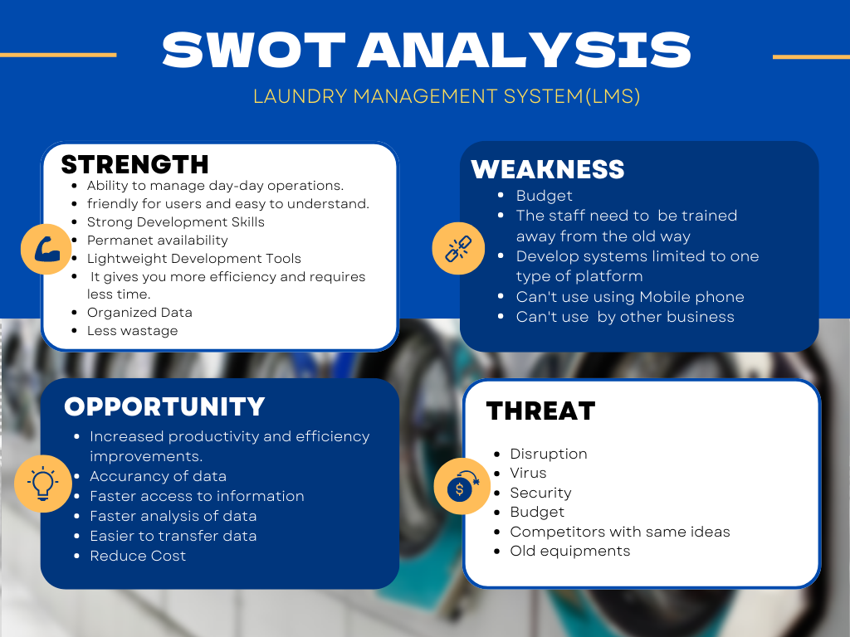

# VII. The Four Ps of Marketing a New Venture

**Product**

A web-based system called the Laundry Management System, which benefits the owners, is the end result of this project. The Laundry Management System (LMS), a new technology, has taken the place of the operating system most laundromats previously utilized. LMS is intended to simplify management in establishments by switching out the manual business process for a systematic one. The LMS's intended audience consists of executives and new hires in the laundry business. The administrative side of this web-based system manages the system's whole workflow. You can add, edit, view, remove, and claim laundry with this product. In terms of features and system design, this product stands out from competitors in a way that will satisfy the intended audience.

**Price**

Web Application - ₱200,000

|  |
| --- |
| **Subscription Plan** |
| **Basic Subscription - Free** |
| * limited access to the system. * 2 users * Limited data can be added to inventory. * Adding Customers Up to 10 * With watermarks |
| **Premium Subscription - ₱** 300/monthly plan  **₱** 3000/Annual plan |
| * Unlimited access to the system * Unlimited Users * Unlimited Adding, Editing and Delete the data of customer * Unlimited Adding, Editing and Delete in Supply list * Unlimited Adding, Editing and Delete in Laundry Type * Unlimited Adding, Editing and Delete in Inventory * No watermarks on printing reports |

**Promotion**

1. **Social Media**

Social media is one of the most effective ways to market a web application. The reason behind this is that social media platforms allow you to reach out to a wide variety of people who are interested in your product. This helps you with promoting your brand as well as increasing its visibility. You can also get feedback from clients about your product and make changes accordingly.It's a good idea to promote your Web application on social media because it allows you to reach people who aren't aware of the product yet but who may be interested in it. Social media is a great way to connect with those people, If you're promoting the Web app there, they'll have a chance to learn more about your product and get excited about trying it out. Advertise our app on social media and other websites to get as many eyes on it as possible, and then watch your number of downloads start climbing.

1. **Ads**

Promoting our Web application using ads is a great way to get more people to download and use it. Ads are another great way to get your app in front of potential users. You can choose from several different kinds of ads, including display ads (which appear as banners on other websites) or video ads (which play automatically when someone visits a page). We have the ability to reach a large audience with minimal investment, and this is something that we hope will help us generate interest in our product.

**Place**

The place we can possibly sell our product is in the following:

1. **Direct to the laundry owner**

Laundry shops are an old breed of retail that has somehow survived in today's technological market. Some laundromats are unaware that we have items like this to help their business. One of the most effective ways we can sell the product is by approaching the owner of a laundry shop where we are selling our product.

1. **Company’s own website**

Our company, IT Squad, is developing the first website where we can sell all our products that we’ve developed. We are in the business of providing a selling experience directly to consumers and businesses. The basic idea would be for us to sell directly without any middlemen from other businesses. It will also be a way for business owners to have access to our products easily. Another thing we will do is provide customer support directly so our customers can buy anything they need at any time with no hassle. We are looking for ways to expand into new markets, new products and services, geographic territories and channels of distribution.

1. **Market Place**

The web application market has many opportunities for developers. We believe that our web app has a competitive advantage in that it attracts many laundry owners or any buyer with an interest in our company’s product because of the diversity of its features. Selling your app in the market place is the best way to start a business. There are billions of people who use smartphones, and many of them download apps every day. The market is the right place because it's based on an online website and has easy access to global buyers.

# VIII. Writing Business Plan

1. **Company Description**

The IT Squad began as a campus group in an IT course at Phinma-University of Pangasinan, founded by Lady Ann Mariel Sabangan Bravo after she was assigned as a leader in our group in the year 2022. Together with Lilibeth Cruz, Erica De Vera, Erl John Larrobis, and Jim Michael Enrico, we continued it, and we built a friendship that has the same goals, which is why the IT squad was created. We are a team of people who are passionate about innovation. We believe that innovation is the best way to solve problems and make the world better. Our mission is to create the best solution through innovation. By making your idea to be realistic and valuable.

We are a group of students who come from different majors, such as Web Development and System Development. Our team consists of people with different personalities and qualities who share the same vision and passion for innovation. We believe in teamwork because it's not only about having knowledge but also sharing ideas and working together as a team towards a common goal.

Our main goal is to provide solutions to your problems or projects through innovation or creativity, because we believe that every problem has its own solution if you really think hard enough about it! We want to give everyone an opportunity to share their thoughts so they can innovate their ideas into something useful!

1. **Management Team**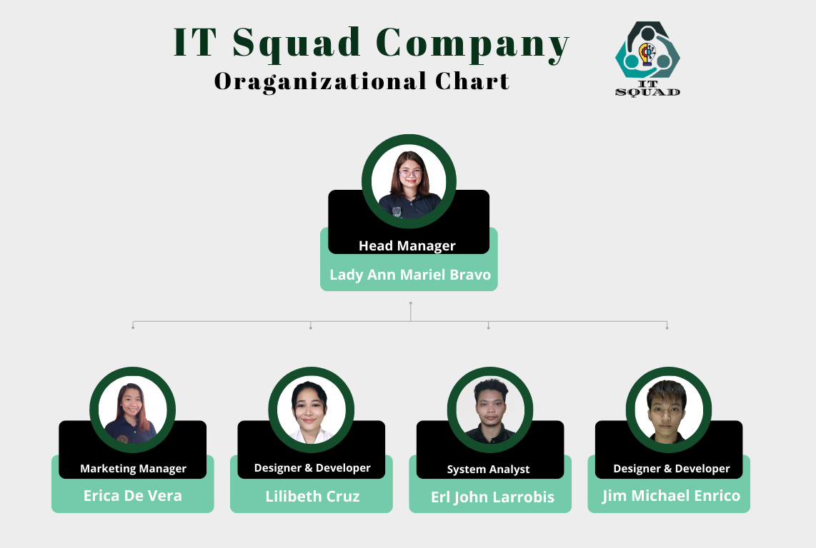
2. **Overall Tetative Schedule**

|  |  |  |
| --- | --- | --- |
| **The year when you plan to open your business:** | **Date:** | **Target output or milestone.** |
| When do you plan to incorporate your IT venture? | 1/2024 | The IT Squad will be a legal business. |
| Target completion date of prototypes? | 6/2024 | The prototype, including wireframes, mockup, and website, is complete. |
| When do you plan to work on the rental or acquisition of facilities/equipment needed? | 12/2024 | To have an office to provide our employees with some of the things they need to be productive and happy. |
| When do you plan to obtain your critical financing? | 3/2025 | Critical financing is complete at this time. |
| Date when you plan to meet with your business partners. | 6/2025 | IT Squad business partners are complete. |
| Date to operationalize the production/testing: | 9/2025 | Starts production testing. |
| Date when you plan to launch the soft opening of your business | 1/2026 | This date was chosen because it is a slow time for our industry and will allow us to iron out any kinks before we officially open our doors to customers. Because customers and clients are looking for new opportunities and ways to improve their lives, so they're more likely to be open to trying out a new company and product. |

1. **Opearations Plan**

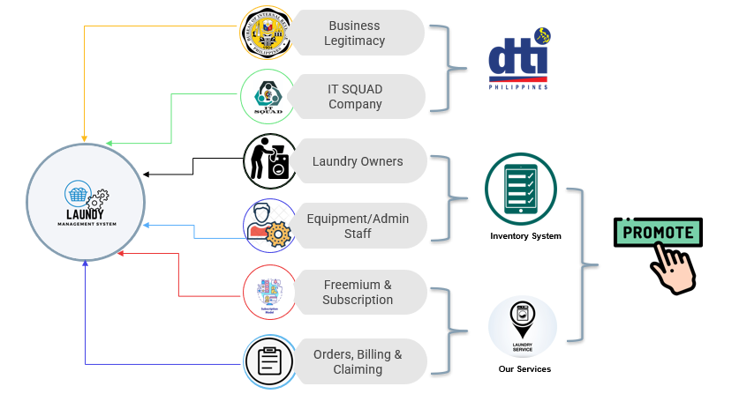

For legal reasons, the Laundry Management System must be registered as a real company, thus we must apply to the appropriate organization for a business permission and submit a DTI registration. The laundry owners need a safe place for their business, the required equipment, and they also need to engage administrative staff to manage day-to-day operations, notably the inventory system. According to the business models, all consumers have access to the Freemium and Subscription plans, and the LMS's capabilities enable the company to offer its services. This website can be promoted using social media, ads, and sponsored search advertising to demonstrate to everyone the greatness and dependability of it.

# IX. Raising Capital

When you are starting your own business, it is important to think about how you will raise capital. Your startup will need money to hire employees and build up your inventory. You may also need money to create a website, or purchase expensive equipment. There are many ways that you can raise capital for your new business, but some methods are better than others. If you choose the wrong method of raising capital, it could put your company at risk of failure.

One way to raise capital is through crowdfunding. Crowdfunding allows people who want to invest in your business to do so on an individual level instead of through banks or other financial institutions that might require more information about the company before agreeing to loan money. This method can be effective because there is no minimum amount required when starting up a business with crowdfunding sites like KickStarter and GoFundMe;

There are three ways to raise capital for your new venture: personal funds, family and friends, and Kickstarter.

1. **Personal Funds**

Personal funds are the most straightforward method of raising capital but there are downsides to using personal funds: you'll have to pay for everything out of pocket, which means you'll have very little left over for reinvesting in the business. You may also find yourself unable to make enough profit from your business in order to generate any kind of return on investment—and so you won't be able to take advantage of that money if you ever want or need it back down the line. However, the good news is that with this method, there are no strings attached; you don't have to pay back investors or anyone else. The bad news is that if your business isn't profitable within a few years, you'll have to start over with something else entirely—or go back to working for someone else instead.

We are a couple of young professionals who have been working hard to save money in order to start a business. Our plan is we will first do the corporate work and when we have enough money and savings we will start the business and use our personal funds to finance our business. We believe that by doing this, we will be able to develop a better understanding of how things work in the corporate environment, which can help us make better decisions when it comes time to start our own business.

1. **Family and Friends**

If you have family or friends who are willing to invest in your company, you have an advantage over other entrepreneurs trying to raise capital. You already know these people well, so they're more likely to trust your vision for the company than someone they don't know well. They may also be willing to put up more than just their money—they might help by offering advice or referrals as well as providing capital. But there are some things to consider before taking this route: first and foremost, it's important to make sure that any money from friends or family is treated as an investment and not a gift. Family and friends can be a valuable source of capital, but keep in mind that they are not professional investors. If you want to raise funds from them, be prepared to explain your business plan in detail and make sure they understand the risks involved.

We have decided to ask our friends and families who believe in us to invest and trust us to our project. We will try to convince them that we are serious about this project by showing them the progress of the project. It is important that they believe in us so that they will help us with their investment.

1. **KickStarter**

This is by far the best option because it allows me to reach out to an audience that wants to support me and help me make my dream come true! The best part about using Kickstarter is that it opens up opportunities for collaboration with other professionals. You can learn from them and grow your network of connections. You'll also be able to work on projects with people who have similar interests as you, which will help inspire you to keep making great website/ web app. However, there's no guarantee that your campaign will be successful (and even if it is, there are costs associated with running one), but it can help get the word out about what you're doing and generate interest from potential investors down the line.

Our plan is to try a Kickstart campaign to fund our project. We believe that the best way to fund this project is through the Kickstart campaign because it will help us reach our target audience and get the word out about our product. We know that our target audience is interested in investing in startups, and we have found that Kickstarter has a large following of people who would be interested in investing in us.

X. The New Venture Team and Business Ethics

**Lady Ann Mariel S. Bravo** is the head manager because she is the owner of IT Squad company. She is responsible for the overall management of the company.

Her responsibilities include:

-Managing all the employees of the company, which means making sure they're doing their jobs correctly and that they are happy working for her.

-Making sure that all of her employees are doing what they need to do in order to produce great products for customers who need them.

-Making sure that everything is running smoothly and efficiently in her company so that customers can get what they want when they want it without any problems getting in their way.

-The head manager will also be responsible for ensuring that each employee has the tools they need to do their job effectively, which may include providing them with additional training or resources as needed.

**Erica Mae De Vera** is the Marketing Manager. She is responsible for managing all marketing efforts, handling the campaigns, proportions and on how to market the product

Her responsibilities include:

- Creating and implementing marketing plans

- Identifying and securing new business leads

- Managing campaigns through execution and measurement

- Working with sales teams to ensure that marketing objectives are aligned with sales goals

**Erl John Larrobis** is the System Analyst he is responsible for the technical analysis, responsible for helping clients understand the needs of their business, and then building a system to meet those needs.He also assists with the implementation of new systems and can provide support to users as needed.

His responsibilities include:

-Developing and maintaining requirements for new or revised systems.

-Collaborating with project managers, developers, and other stakeholders to ensure that software meets the needs of end users.

-Testing software to ensure that it meets functional specifications.

-Planning how to implement new systems

-Helping with user support

**Lilibeth Cruz** is the designer and developer she creates and implements the visual aspects of the website, including text and images. She also designs the user experience and user interface, which are how users navigate through a website. She is also responsible for developing code that will make the website function properly.

Her responsibilities include:

-Designing the pages of the website

-Creating wireframes for each page that shows how it will look like when it's finished

-Creating mockups for each page based on the wireframes so that we can get an idea of exactly what it will look like

-Using coding languages like HTML, CSS, and JavaScript.

-Work with developers to design algorithms and flowcharts.

-Produce clean, efficient code based on specifications.

-Integrate software components and third-party programs.

-Verify and deploy programs and systems.

-Troubleshoot, debug and upgrade existing software.

-Gather and evaluate user feedback.

**Jim Michael Enrico** is also the designer and developer he creates and implements the visual aspects of the website, including text and images. He also designs the user experience and user interface, which are how users navigate through a website. He is also responsible for developing code that will make the website function properly.

His responsibilities include:

-Designing the pages of the website

-Creating wireframes for each page that shows how it will look like when it's finished

-Creating mockups for each page based on the wireframes so that we can get an idea of exactly what it will look like

-Using coding languages like HTML, CSS, and JavaScript.

-Work with developers to design algorithms and flowcharts.

-Produce clean, efficient code based on specifications.

-Integrate software components and third-party programs.

-Verify and deploy programs and systems.

-Troubleshoot, debug and upgrade existing software.

-Gather and evaluate user feedback.

# XI. New Age Source of Income

# **Patreon**

Patreon is an online platform that allows creators like yourself to get support from their fans in exchange for rewards. In other words, if you put out content on Patreon and your fans decide they want to support you financially, they can do so at any level they choose.

This because we can set up a page where people can pledge to pay us monthly, and then we can post our content on that page. We can set up rewards for different levels of payment, and the money is automatically deducted from patrons' accounts each month. And also one of the reasons for this is because it helps them to get more recognition and build their community. As a result, they are able to grow their business in a more efficient way without having to worry about money as much.

For example, if a fan wants to give $1 per month in support of our work, then they can do that—it's entirely up to them! It's all about giving people the opportunity to show their appreciation for the work that we create. And while many people believe there aren't enough paying customers out there for us who aren't famous yet, there are actually tons of people who will pay for quality work if they know about it!

1. **Donation**

Donation will be use as our new age source of income because it is great because people who donates don't require any kind of repayment or contract. They're also fairly easy to set up: we can set up a donation button on our website that allows visitors to donate money when they feel like it.

For example, if we have created a new app that helps people find nearby restaurants, we could set up a donation button that allows users of our app to donate money once per month for use of the service. This would be especially helpful if we were advertising your app as "free," since users wouldn't feel like there was any pressure on them to pay for something they're already getting for free!

1. **Subscription**

Subscriptions allow us to create a recurring revenue stream. This means that we can make money from customers who buy our product or service on a monthly and Annual basis, rather than having to sell them one time. This allows for more reliable and predictable income over time.

For example, if the customer avails our monthly subscription worth 300 pesos our customer will have an unlimited access and can access all our features in our app within a month. We also offers annual subscription worth 3000 pesos this is for our customers who can’t avail the one time subscription and knows that they can’t forever use our product and services.

# XII. Feasibility

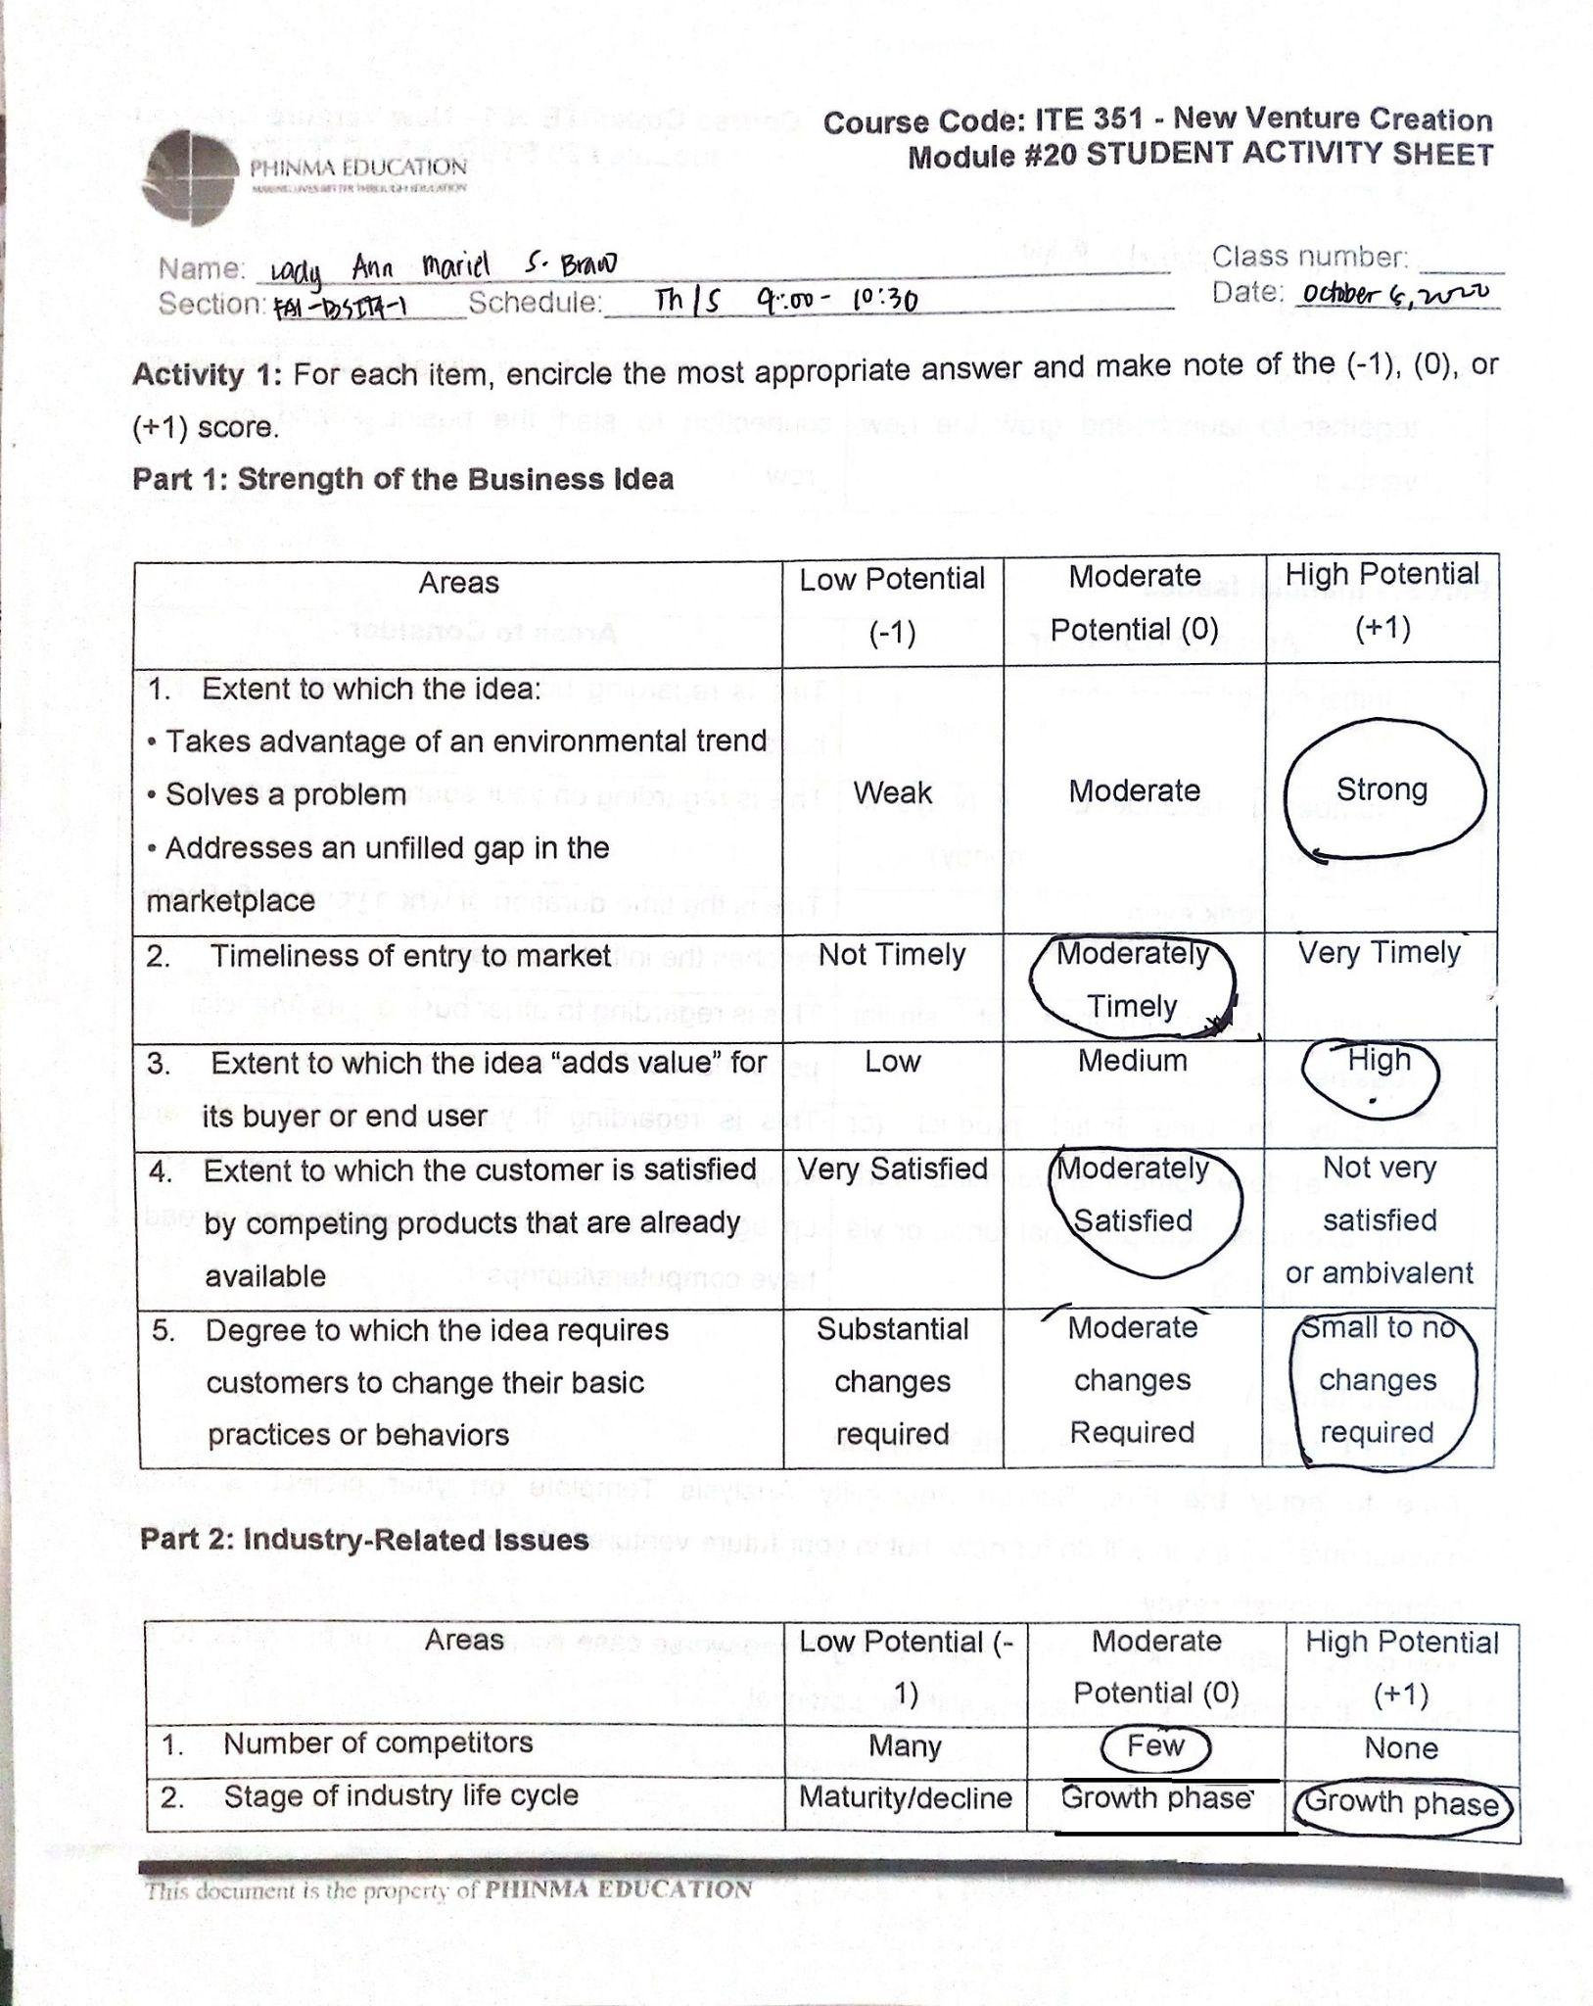

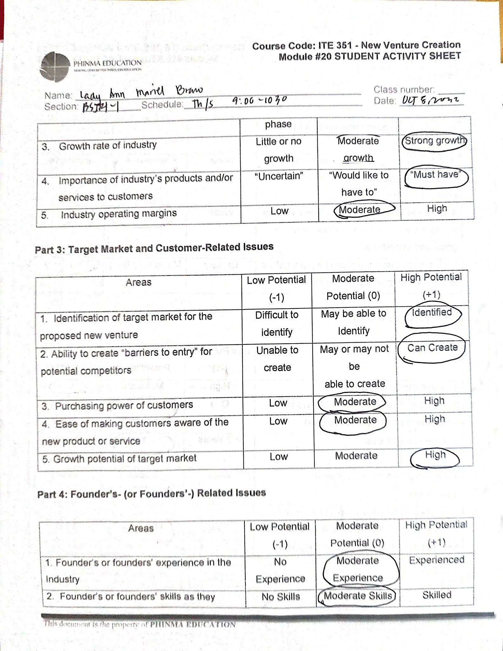

# 

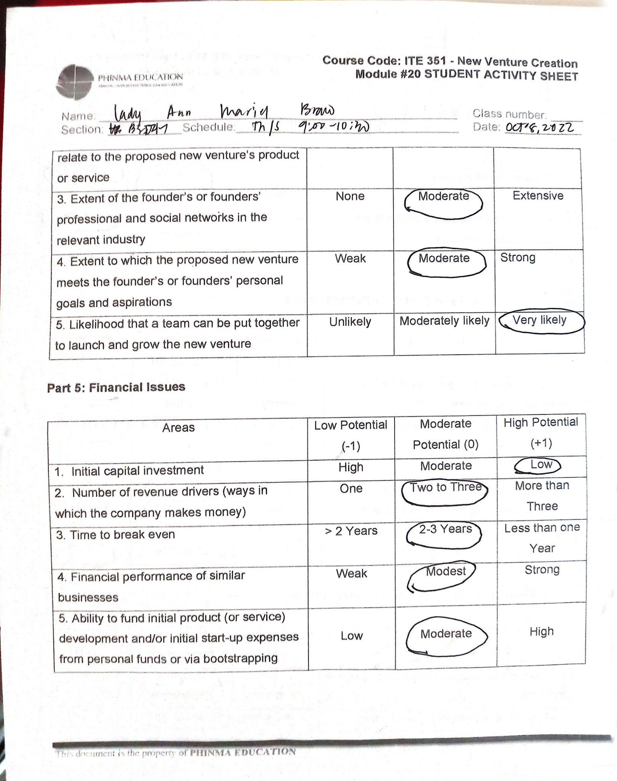

# 

# XIII. Conclusion

In conclusion, the Laundry Management System is a comprehensive solution that can be used to manage all aspects of laundry operations. The system can be used by small businesses and large corporations alike, and it comes with a variety of features that can be customized to your specific needs.

The system will help you save money and time, while also increasing your efficiency and accuracy. In short, it's an invaluable tool for any company involved in laundry management.